Detecting Toxic Behaviour in Online Communities Using Transformer-Based Natural Language Processing
A Comparative Study of Label Granularity Across Two Corpora
Angal Hemanth Reddy
Student ID: A00088732
Supervisor: Dr. Sayed Pouria Talebi
MSc Data Science
University of Roehampton London

Declaration
This report is submitted in partial fulfilment of the requirements for the degree of MSc Data Science at the University of Roehampton London. The work presented is the author's own, except where explicitly acknowledged and referenced. All datasets used are publicly available and are cited accordingly. No part of this work has been submitted for any other award.
Signed: Angal Hemanth Reddy Date: 12/08/2026

Acknowledgements
The author would like to thank Dr. Sayed Pouria Talebi for his supervision and guidance during this project. His focus on detailed early data exploration was essential to shaping the work's direction.

Abstract
Online communities struggle with abusive and toxic communication. The large amount of user-generated content makes manual moderation impractical. This project looks into how to automatically detect toxic language using transformer-based natural language processing. It compares BERT and XLM-RoBERTa to a traditional term-frequency baseline.
The work proceeded in two phases. The first phase used the League of Legends Tribunal corpus, which includes 1,697,193 chat messages from 10,058 moderation cases. An exploratory analysis showed that this corpus lacks the sanction outcome, match result, or player role fields mentioned in the original project specification. This finding required us to reformulate the task as a multi-class classification for offense categories. More importantly, the analysis revealed that labels are recorded at the moderation case level and passed down to every message, leading to significant label inconsistency. Of the 882,549 unique message strings, 59,707 appeared under more than one label. All three model architectures converged within 0.02 macro F1 of each other on this corpus, with the best only reaching 0.286.
The second phase used the Jigsaw Toxic Comment Classification corpus, which contains 159,571 individually labeled comments. In this phase, the equivalent label-conflict test returned zero. The models maintained the same architecture and evaluation protocol, and they showed significantly better performance. BERT achieved a mean column-wise ROC AUC of 0.9895 and a macro F1 score of 0.628. Adjusting the per-label threshold based on validation data further increased the macro F1 score to 0.693, representing a 10.4 percent improvement without changing the model. Attention-based attribution revealed that predictions are influenced by profanity and identity-related vocabulary. It also identified a consistent pattern of false positives, where figurative violence in gaming discussions is wrongly classified as a real threat.
The main finding is that the level of annotation detail, not the model size, was the main limitation in the first dataset. Identical models more than doubled their macro F1 score when switching from inherited case-level labels to specific instance labels. This project provides a measurable assessment of this effect and shows that adjusting thresholds is a cost-effective way to address significant class imbalance.

Contents
Declaration 2
Acknowledgements 3
Abstract 4
List of Tables 8
Introduction 9
Problem Description, Context and Motivation 9
Objectives 9
Methodology 10
Design 10
Testing and Evaluation 10
Project Managment 10
Technologies and Processes 11
Legal, Social, Ethical and Professional Considerations 12
Background 12
Structure of Report 13
Literature – Technology Review 13
Literature Review 13
Early Approaches: Lexicons and Feature Engineering 14
Neural Approaches Before the Transformer 14
Transformer Architectures for Text Classification 15
Evaluation Under Class Imbalance 15
Multi-Label Classification 16
Class Imbalance and Threshold Selection 17
Annotation Quality and Its Effect on Achievable Performance 17
Cross-Domain Generalisation and Bias 18
Technology Review 18
Summary 19
Implementation 20
Development Environment 20
Phase One: The Tribunal Corpus 20
Dataset Inspection 20
Identification of Label Noise 20
Aggregation to Case Level 21
Phase One Modelling 21
Preprocessing Decisions 22
Hyperparameter Selection 22
Compute Budget and Reproducibility 23
Rationale for Changing Corpus 23
Phase Two: The Jigsaw Corpus 24
Dataset Characteristics 24
Baseline Implementation 25
Transformer Implementation 25
Threshold Calibration and Interpretability 26
Per-Label Threshold Optimisation 26
Attention-Based Attribution 26
Implementation Challenges 27
Library Version Incompatibility 27
Apparent Checkpoint Loading Failures 27
Training Instability in XLM-RoBERTa 27
Evaluation Methodology 28
Phase One Results: Tribunal Corpus 28
Phase Two Results: Jigsaw Corpus 29
Threshold Calibration 30
Interpretability Analysis 32
Cross-Corpus Comparison 33
Statistical Considerations 34
Comparison with Published Results 34
Related Works 35
Evaluation Against Objectives 35
Summary of Findings 37
Limitations 37
Future Work 38
Controlled Study of Label Granularity 38
Domain Adaptation for Gaming Discourse 39
Systematic Bias Audit 39
Comparison of Imbalance Strategies 39
Model Scale and Architecture 39
Reflection 40
References 41
Appendices 42
Appendix A Artefact and Datasets 42
A.1 Artefact Description 42
A.2 Datasets 42
A.3 Reproducing the Results 43
A.4 Output Files 43
Appendix C Hyperparameter Configuration 45
Appendix D Key Code Listings 45
G.1 Multi-label weighted loss 45
G.2 Label-conflict measurement 46
G.3 Per-label threshold optimisation 46
G.4 Attention attribution 46
G.5 Version-agnostic training arguments 46

List of Figures
Figure 1 Label prevalence and number of labels per comment in the Jigsaw corpus
Figure 2 Comment length percentiles for Jigsaw and the effect of offender-only filtering on Tribunal documents
Figure 3 Most frequent misclassifications on the Tribunal corpus and the effect of case-level aggregation
Figure 4 Gantt chart of planned against actual project progress
Figure 5 BERT training and validation loss on the Tribunal corpus and validation F1 by epoch
Figure 6 Model comparison on the Jigsaw corpus with ROC AUC on a restricted axis
Figure 7 All evaluated models across all reported metrics including the calibrated configuration
Figure 8 Per-label ROC AUC against F1 at the fixed 0.5 threshold
Figure 9 Ranking quality plotted against label frequency
Figure 10 Per-label F1 before and after threshold calibration
Figure 11 Aggregate effect of calibration and the relationship between label frequency and optimal threshold
Figure 12 Label conflict in each corpus and the macro F1 achieved by identical architectures
Figure 13 Model dispersion on each corpus
Figure 14 Most frequently attended tokens across the most confidently toxic predictions

List of Tables
Table 1 Label prevalence in the Jigsaw corpus
Table 2 Model performance on the Tribunal corpus, four-class case-level
Table 3 Model performance on the Jigsaw corpus, six-label multi-label
Table 4 Effect of per-label threshold calibration
Table 5 Comparison of the two corpora and resulting performance
Table 6 BERT per-label classification report, Jigsaw test partition
Table 7 BERT per-label results after threshold calibration
Table 8 Aggregate metrics before and after calibration
Table 9 Complete hyperparameter settings for all transformer experiments
Table 10 Positive-class weights applied in the multi-label loss function
Table 11 Tribunal corpus label distribution before filtering
Table 12 Effect of modelling strategy on the Tribunal corpus
Table 13 Most frequent misclassifications, Tribunal corpus
Table 14 Artefact notebook inventory

Introduction

Problem Description, Context and Motivation
Toxic communication in online communities is a well-known issue that impacts participation, wellbeing, and the viability of platforms. Competitive multiplayer gaming and large collaborative sites like Wikipedia face ongoing harassment, abuse, and hostility directed at individuals. The large amount of user-generated content on these platforms makes complete human moderation both costly and impractical. This situation has led to a strong interest in research on automated detection.
The industrial need is urgent. Platform operators face growing regulations to find and address harmful content. Moderation teams need tools that can organize review queues without completely eliminating human judgment. The research need is also evident. Abusive language depends on context, often uses irony, and comes in quickly changing slang, which makes traditional text classification methods difficult.
Transformer architectures have greatly improved text classification since their introduction. This project looks at how well they apply to the problem of detecting toxicity. During the work, another motivation arose. The quality of supervision in a corpus turned out to be a more important factor in achieving good performance than the choice of architecture. This finding influenced the project's direction.

Objectives
The goal of this project is to create and assess transformer-based classifiers that detect toxic language in online communities. We will also identify the factors that limit their performance. The specific objectives are:
- To systematically assess the data quality of a candidate corpus and see if the available variables support the intended classification task.
- To set up a basic classifier and a simple majority-class standard for fairly evaluating learned models.
- o adjust and compare BERT and XLM-RoBERTa classifiers using the same data set and evaluation method.
- To assess models with metrics suitable for severe class imbalance and to explore the impact of adjusting decision thresholds.
- To use interpretability techniques that reveal which linguistic features influence predictions and to find consistent failure modes.

Methodology

Design
The project uses an experimental, quantitative design. We train models on labeled data and evaluate them on separate partitions. We compare performance against a classical baseline and a simple reference classifier. The design is comparative in two ways: across different model architectures within a dataset and across datasets while keeping the architecture the same.

Testing and Evaluation
Evaluation uses quantifiable metrics chosen for their suitability in cases of class imbalance. Macro-averaged F1 is used for multi-class evaluation because it treats each class equally, no matter the support. Mean column-wise ROC AUC is used for multi-label evaluation since it does not depend on thresholds and matches published work on the corpus. A majority-class classifier is assessed with every model to set the basic performance baseline.

Project Management
The project was organized as a series of steps: proposal, literature review, data exploration, baseline modeling, transformer fine-tuning, and report writing. Figure 1 shows progress compared to that plan. It compares the original timeline for each step with the actual time it took to complete them. 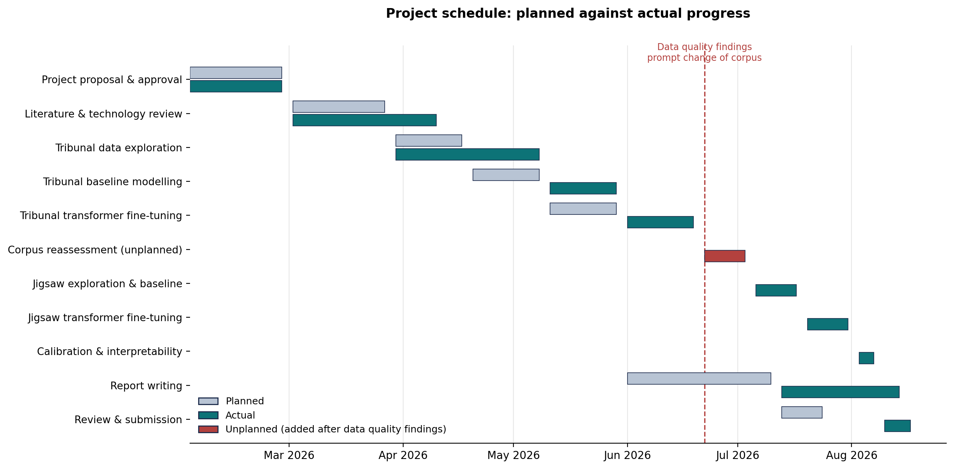
Figure 1: Project schedule showing planned against actual progress. The dashed marker indicates the point at which the data quality findings prompted a change of corpus

The early phases mostly went according to schedule, but the literature review and Tribunal data exploration took longer than expected. The exploration phase, in particular, exceeded its time allocation because the schema inspection and label conflict analysis outlined in Section 3.2 were not anticipated during the planning phase. These tasks required much more effort than a routine data quality check.

The most significant change came from these findings. The original plan assumed a single corpus and did not include time for reassessment. However, discovering that the Tribunal labels were inherited at the case level, along with the absence of expected variables in the corpus, led to an unplanned phase of reassessing the corpus. This is depicted separately in Figure 1 and represents work not accounted for in the original schedule. The three subsequent phases covering the Jigsaw corpus were also entirely unplanned, as the original schedule accounted for one dataset instead of two.

Rather than abandoning the schedule, adjustments were made in response to these changes. Two key decisions made it possible to complete the extra work within the remaining time. First, the Tribunal analysis was kept instead of discarded. This meant that the effort already invested contributed to the final report as the main evidence for changing the corpus, rather than being wasted. Second, the modeling pipeline developed for the Tribunal corpus was reused for the Jigsaw corpus, with changes limited to the multi-label formulation. This reduced the second phase of experimental work to a fraction of the time required for the first phase. Consequently, report writing was compressed and overlapped with the final experimental phase instead of following it, and an extension was requested to accommodate the remaining work.

An iterative approach to project management proved more effective for this project than the linear plan originally adopted. A method focused on short cycles of assessment, implementation, and review would have identified the data quality problem earlier. It would have treated the resulting change of direction as a normal part of a review cycle rather than as a deviation from the plan. This is discussed further in the reflection in Chapter 5. Supporting evidence for the schedule shown here, including the underlying task records, is provided in Appendix B.

Technologies and Processes
An iterative, incremental approach was used. Each cycle included data assessment, implementation, evaluation, and review. Findings from one cycle informed the design of the next. This was crucial. The label-quality problem identified in the first cycle led to the introduction of a second corpus, which a linear plan would not have allowed.

Legal, Social, Ethical and Professional Considerations
Both corpora are publicly available for research use and do not include any direct personal identifiers. Usernames and account references were not used as model inputs. No new data collection involving human participants took place, and the necessary institutional ethics approval was obtained.
The social implications require a careful statement. A toxicity classifier used in production would affect decisions that impact individual users. Errors can have uneven consequences; a false positive could unjustly punish legitimate speech, while a false negative allows harm to continue. The interpretability analysis in Chapter 4 showed a clear pattern of false positives. It found that figurative violence in gaming discussions was classified as real threats, which clearly highlights the risk involved.
A further ethical concern is representational bias. Models trained on identity-targeted abuse learn connections with identity terms. As a result, they may penalize neutral discussions about protected characteristics. This project reports this risk but does not resolve it. Using the models would require careful bias checks that go beyond what this work covers.

Professionally, the work follows the BCS Code of Conduct. It openly shares model limitations, including the quality issues with the first dataset and the single-seed nature of the experiments. These limitations are presented clearly instead of being left out for a more positive portrayal.

Background
The technical foundation of this project is the transformer architecture, which replaced recurrent processing with self-attention. This change allowed for efficient training on much larger datasets [3]. Pretrained language models based on this architecture are trained on large collections of unlabelled text and then fine-tuned for specific tasks using smaller labelled datasets. BERT [1] set the standard for classification tasks with a masked language modeling approach, while XLM-RoBERTa [2] expanded this model across one hundred languages.

The application area of this project, automated abuse detection, is a well-established field with recognized challenges. One significant challenge is disagreement among annotators. The line between offensive and simply impolite language is unclear, and the labels created by human raters show significant inconsistency [4], [5]. This project’s findings broaden that observation from disagreements among annotators to a structural variation due to label inheritance.

Structure of Report
Chapter 2 reviews the related literature and the technologies used. Chapter 3 describes the implementation in both experimental phases, including the data quality analysis that prompted the change of corpus. Chapter 4 presents and evaluates the results, including the cross-corpus comparison that is the main finding. Chapter 5 concludes, points out areas for future work, and reflects on how the project was conducted.

Literature – Technology Review

Literature Review
Research into automated abuse detection started before the transformer era. Early methods used lexicon matching and manually created features. These methods worked reasonably well for explicit profanity but struggled with implicit hostility, sarcasm, and context-dependent insults. Later, feature-based machine learning with term-frequency representations became the main approach and still serves as a solid baseline.

Davidson et al. [4] looked at the difference between hate speech and offensive language on Twitter. They created a three-class corpus and found that classifiers often confused the two categories. Their analysis suggested that this confusion stems from genuine ambiguity in the concepts rather than flaws in the modeling. They also noted that annotators disagreed significantly on borderline cases. This result is relevant to what is discussed in Chapter 4 of this work, where similar confusion appeared between overlapping offense categories.

Founta et al. [5] performed a large crowdsourced annotation of abusive behavior on Twitter. They studied how the design of the annotation schema impacts the reliability of labels. They reported that categories that seem distinct to schema designers are often applied inconsistently by annotators in practice. Wulczyn et al. [6] took a different route, using multiple independent annotations for each item to create the Wikipedia personal attacks corpus. This corpus is the source of the Jigsaw dataset used in this project. The redundancy in their annotation design likely explains the label consistency seen in Chapter 3.

Early Approaches: Lexicons and Feature Engineering
The earliest automated methods for detecting abusive language relied on matching keywords and lexicons. A curated list of profane or offensive terms was compared to incoming text, and a match would trigger a flag. These systems are simple to implement and fully transparent. They still play a role in moderation processes as a first-pass filter. However, their limitations are clear. Lexicon matching cannot tell the difference between using and mentioning a term. For instance, a comment that quotes abuse to report it is flagged like the actual abuse. It also fails to identify hostility expressed without profanity, which makes up a large part of harmful content. Additionally, people can easily evade these systems by using deliberate misspellings, character substitutions, and altered spacing, which are tactics that spread quickly in moderated communities.

Feature-based machine learning addressed some of these shortcomings. By representing documents as bags of words or character n-grams weighted by term frequency and inverse document frequency, and using support vector machines or logistic regression for classification, these models learned from data instead of relying solely on curated lists. Character n-gram features were particularly effective against deliberate obfuscation because a misspelling shares most of its character sequences with the original term. This group of approaches remains a strong and often underestimated baseline. This is highlighted in Section 4.2 of this report, where a term-frequency classifier performed similarly to fine-tuned transformers on a noisily labeled dataset.

The main limitation of feature-based methods is how they treat words as separate units. A bag-of-words representation cannot differentiate between an insult aimed at a person and the same words used in quotes, negations, or ironic statements. This is because word order and syntactic relationships are ignored. This limitation led to the development of representations that capture context.

Neural Approaches Before the Transformer
Distributed word representations trained on large unlabelled text collections marked an early step toward contextual modeling. They map words to dense vectors, where similar meanings relate to nearby points in space. Classifiers based on these embeddings can generalize to words not encountered during supervised training, as long as those words appear in the unlabelled pretraining data. However, the representation is static. A word gets the same vector no matter the sentence it's in, so it misses out on capturing multiple meanings and context-dependent significance.

Recurrent architectures, especially long short-term memory networks, process text in order and keep a hidden state that summarizes previous tokens. This approach allows for true contextual representation. Convolutional networks, on the other hand, analyze token sequences simultaneously, finding important n-gram patterns all at once rather than in order. Both approaches have been widely used for abuse detection and work better than traditional feature-based methods, especially in identifying implicit hostility. Their drawbacks lie in computation and representation. Sequential processing is hard to parallelize, and recurrent states weaken over long distances, even with gating mechanisms meant to help.

Transformer Architectures for Text Classification
Vaswani et al. [3] introduced the transformer, replacing recurrence with multi-head self-attention. The architecture computes representations of each token based on all other tokens in the sequence. This allows for parallel computation and captures long-range dependencies more effectively than sequential models.
Devlin et al. [1] introduced BERT, using bidirectional transformer encoders that are pretrained through masked language modeling and next-sentence prediction. For classification, a special classification token is added to the input, and its final-layer representation is sent to a task-specific output layer. This project uses this same mechanism.
Liu et al. [7] showed with RoBERTa that BERT was significantly undertrained. They found that removing the next-sentence prediction goal while training longer on more data leads to consistent improvements. Conneau et al. [2] extended this to the multilingual setting with XLM-RoBERTa, which was trained on filtered CommonCrawl data covering one hundred languages with a shared vocabulary of about 250,000 subword tokens. Their results demonstrate strong cross-lingual transfer, but they also note that multilingual models can perform worse than monolingual models on high-resource languages. This aligns with the findings reported in Section 4.3.

Evaluation Under Class Imbalance
Toxicity corpora are often imbalanced, with harmful content making up a small portion of the total instances. This imbalance has direct effects on how we approach the methodology. Accuracy is not helpful when a rule based on the majority class achieves a high score without actual learning. Weighted averages of precision, recall, and F1 are similarly influenced by the majority class.

Macro-averaging solves this issue by weighing each class equally, regardless of support. This method reveals failures in rare categories that the aggregate metrics often hide. Threshold-independent measures like ROC AUC evaluate ranking quality separately from the choice of decision boundary. The difference between a high AUC and a low fixed-threshold F1 is a known sign that a classifier ranks correctly but is assessed at an unsuitable operating point. Section 4.4 of this report demonstrates that situation empirically and quantifies the recovery possible through calibration.

Multi-Label Classification
The Jigsaw corpus presents a multi-label problem rather than a multi-class one. A comment can be toxic, obscene, and an insult at the same time, and these categories overlap. This distinction has important methodological implications that are often overlooked.

The standard method is binary relevance. In this approach, a separate binary classifier is created for each label. It is easy to implement and served as the classical baseline in this project through a One-vs-Rest wrapper. However, it has a limitation: it ignores label dependencies. The strong connection between the obscene and toxic categories provides no information under binary relevance because each classifier is trained independently. Alternative methods, like classifier chains and label powerset systems, explicitly model dependencies but add complexity. Label powerset approaches can also lead to an exponential increase in the number of effective classes.

Neural architectures tackle the multi-label problem more naturally. A single network produces one logit for each label, and binary cross-entropy is applied separately to each. The shared encoder allows representations to be learned together across labels, even though decisions are independent. This captures dependencies implicitly through the shared representation instead of through the output structure. This approach was used for the transformer experiments in this project.

Evaluating multi-label classifiers requires careful consideration of averaging methods. Micro-averaging sums true positives, false positives, and false negatives across all labels before calculating the metric. This method gives equal weight to each decision and is influenced by frequent labels. Macro-averaging, on the other hand, calculates the metric for each label and averages them, giving equal weight to each label regardless of how often they appear. Both methods are included in this project because they address different questions: micro-averaging reveals overall decision quality, while macro-averaging highlights performance on rare categories.

Class Imbalance and Threshold Selection
Abuse detection datasets are usually imbalanced, and the Jigsaw dataset is particularly skewed, with the rarest label appearing in less than 0.3 percent of comments. The literature discusses three ways to address this issue. Resampling changes the training distribution by either oversampling minority instances or undersampling majority ones. While this method is straightforward, it risks overfitting to duplicated instances or losing important negatives. Cost-sensitive learning adjusts the loss function, making errors in minority classes carry a heavier penalty. This approach keeps the entire dataset intact, and it is the method used here through positive-class weighting. Focal loss builds on this idea by reducing the influence of well-classified examples, allowing training to focus on harder cases.

Another important but often overlooked aspect is the decision threshold. Classifiers that output calibrated probabilities usually set a threshold at 0.5. However, this default is only suitable when the classes are balanced and misclassification costs are equal, neither of which is true in this case. Furthermore, when cost-sensitive training is applied, the predicted probabilities are intentionally adjusted, making the default threshold unsuitable. Section 4.4 illustrates this with data: optimal thresholds for the Jigsaw labels range from 0.78 to 0.95, and adjusting to these values improves the macro F1 score by 10.4 percent without changing the model. The literature often views threshold selection as a minor detail rather than a significant design choice. The findings presented here indicate that this perspective downplays its importance.

Annotation Quality and Its Effect on Achievable Performance
A common issue in abuse detection research is that the limits on classifier performance often come from the labels instead of the models. Davidson et al. [4] found that the difference between hate speech and offensive language caused confusion among annotators and was challenging for classifiers. Founta et al. [5] showed significant disagreement on borderline categories in large-scale crowdsourced annotations. Wulczyn et al. [6] tackled this problem by gathering multiple independent judgments for each item, using the combined results as the label instead of relying on any single annotator.

This project faced a different but related challenge. In the Tribunal corpus, the issue is not disagreement among annotators but that labels were recorded at a broader level than the instances being classified and were passed down. The result is similar to annotator disagreement in how it impacts the training signal, but it stems from the structure of the data rather than human judgment. This difference is important: annotator disagreement can be reduced through redundant annotation, while inherited labels need either aggregation to the level where labels were assigned, as discussed in Section 3.2.3, or reannotation at a more detailed level.

Cross-Domain Generalisation and Bias
Two more concerns frequently appear in the literature and are directly related to the findings discussed in Chapter 4. The first is cross-domain generalization. Models trained on one platform often perform poorly when used on another. This happens because language norms, vocabulary, and the rules for acceptable expression vary between communities. Section 4.5 of this report provides a specific example: a model trained to analyze Wikipedia discussions misclassified figurative violence typical in gaming conversations as actual threats. This error would lead to many false positives if the model were used on a gaming platform without adjustments.

The second concern is representational bias. Models designed to detect identity-based abuse learn to associate identity terms with specific meanings and may assign higher toxicity scores to neutral or positive statements that include protected characteristics. This issue has been observed in several toxicity classifiers and poses a serious challenge for responsible usage. It particularly affects the groups the system aims to protect. The project did not conduct a dedicated bias audit, which is noted as a limitation in Chapter 5.

Technology Review
Python was chosen as the programming language because of its strong support in machine learning. The Hugging Face Transformers library [9] offers pretrained checkpoints and a training framework, and it was used with a PyTorch backend. Scikit-learn [8] provided the basic baseline, tools for splitting data, and evaluation metrics. Kaggle Notebooks served as the execution environment. It offered GPU acceleration without needing local hardware and kept executed outputs along with the source code, which helps with reproducibility.

We looked at other options. TensorFlow has similar features, but the integration with PyTorch in the Transformers library is smoother. Larger models like DeBERTa or RoBERTa-large might boost performance, but we chose base-sized models. This allowed us to train two architectures within the available computing budget while keeping the model size the same for a fair comparison.

Summary
Three conclusions from this review shaped the work that follows. First, annotator disagreement is a recognized and significant challenge in abuse detection research. Several authors report that different categories are applied inconsistently in practice. This informs the interpretation of the label conflict discussed in Chapter 3. Second, the pretrain-and-fine-tune method is well known for text classification. The base-sized BERT and XLM-RoBERTa models are suitable and comparable for evaluation. Third, evaluating under severe imbalance needs metrics that do not favor majority-class prediction. This led to using macro-averaged F1 and threshold-independent ROC AUC, along with a basic reference classifier.

Implementation
This chapter explains how the methodology was applied. The work happened in two phases. The first phase used the League of Legends Tribunal corpus mentioned in the project proposal. An exploratory analysis of that corpus showed structural problems that made the task impossible to complete. These findings led to the second phase, which used the Jigsaw Toxic Comment Classification corpus. Both phases are reported, because the first one provides the reasons behind the decisions made in the second.

Development Environment
All experimental work took place in Kaggle Notebooks, which provided a Python 3 kernel with GPU support. Training utilized an NVIDIA Tesla T4. The main libraries included pandas and NumPy for data handling, Matplotlib and Seaborn for visualization, scikit-learn [8] for standard modeling and metrics, and Hugging Face Transformers [9] with a PyTorch backend for fine-tuning. To ensure reproducibility, we saved executed notebook versions along with the source and outputs.

Phase One: The Tribunal Corpus

Dataset Inspection
The Tribunal corpus includes 1,697,193 chat messages from 10,058 moderation cases. An inspection of the schema found that fields expected in the original proposal were missing. There is no binary sanction outcome, no match result, and no player role field. The only variable that could be used as a target was most_common_report_reason, which records the offence category for which the reported player was cited. As a result, the task was redefined as multi-class classification of offence type.

Identification of Label Noise
A significant issue came up during quality assessment. Labels are recorded at the case level instead of the message level. Every message in a case inherits the offence category of that case, regardless of its content. This means a harmless message within a case marked for verbal abuse is classified as verbal abuse.

We measured the extent of contamination by grouping messages with the same text and counting their different labels. Out of 882,549 unique message strings, 59,707 had more than one label, which is about 6.8 percent. Since the test requires exact string matches, this figure is a conservative lower limit on the true label inconsistency.

Aggregation to Case Level
Two strategies were compared. In the first strategy, each message was treated as a separate instance with its own label. In the second strategy, all messages in a case were combined into one document and classified based on the case label. A TF-IDF and logistic regression classifier reached a weighted F1 score of 0.188 with the first strategy and 0.297 with the second, which is about a 58 percent improvement. Case-level aggregation was used for all later Tribunal experiments.

Two refinements followed. Categories with fewer than 200 cases were excluded, which removed Spamming (167 cases) and Inappropriate Name (30 cases), leaving four classes. Messages were filtered to include only those sent by the reported player. This decision was based on the idea that messages from teammates and opponents describe others' behavior and add noise. As a result, the average document length decreased from 484 words to 92.
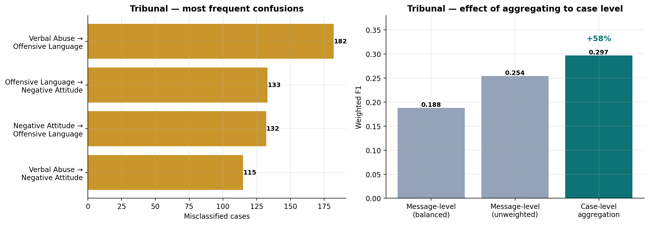
Figure 3: Most frequent misclassifications on the Tribunal corpus (left), and the effect of aggregating messages to case level (right)

Phase One Modelling
Four models were tested on a shared stratified case-level partition. These included a majority-class dummy as the basic benchmark, a TF-IDF and logistic regression baseline, and fine-tuned BERT-base-uncased [1] and XLM-RoBERTa-base [2]. We used class-weighted cross-entropy throughout. A custom Trainer subclass was created to apply class weights since the default training loop does not include a weighting parameter.

In an initial run with XLM-RoBERTa at a learning rate of 2e-5, the model fell into constant prediction, resulting in a macro F1 score that matched the dummy classifier. Lowering the learning rate to 5e-6 and extending the warm-up to twenty percent of the total steps fixed the instability.

Preprocessing Decisions
Preprocessing was kept to a minimum. Common text normalization steps like lowercasing, stopword removal, and stemming were not used for the transformer inputs. Pretrained models expect text that resembles what they were trained on, and their subword tokenizers manage differences in word forms on their own. Stripping the text too much would remove useful information that the model can use. In this case, casing is important. For instance, sustained capitalization often indicates hostile intent.

Two preprocessing steps were taken. Rows with null, empty, or whitespace-only text were removed, as well as rows with encoding artifacts, since they do not add meaningful information. Exact duplicate rows were also removed to avoid having the same instances in both the training and test sets, which would artificially increase reported performance. For the classical baseline, accent stripping was enabled in the vectorizer. This is because term-frequency representations do not treat accented and unaccented versions of words as related otherwise.

Hyperparameter Selection
Hyperparameters were chosen based on published recommendations instead of an exhaustive search due to the available compute budget. The learning rates used are 2e-5 for BERT and 1e-5 for XLM-RoBERTa. These values are within the recommended range of 1e-5 to 5e-5 for fine-tuning. The lower rate for XLM-RoBERTa reflects its larger parameter count and the instability seen in Phase One at higher rates.

Two training epochs were used for the Jigsaw experiments. This count is on the lower end of the typical range and was chosen on purpose. With about 112,000 training instances, a single epoch includes around 7,000 optimization steps. This amount is enough to converge on a task like this, and adding more epochs increases the risk of overfitting without a significant gain. The batch size was set to 16, with a maximum sequence length of 192 tokens. This combination was chosen to fit within the available GPU memory while keeping most of each comment intact.

It is worth noting that this is a single configuration per model, not a tuned one. A systematic search for learning rate, batch size, and sequence length would probably lead to some modest improvements. The lack of such a search is mentioned as a limitation in Chapter 5.

Compute Budget and Reproducibility
Hyperparameters were chosen based on published recommendations instead of a thorough search, given the available compute budget. The learning rates used were 2e-5 for BERT and 1e-5 for XLM-RoBERTa. These rates fall within the recommended range of 1e-5 to 5e-5 for fine-tuning. The lower rate for XLM-RoBERTa accounts for its larger parameter count and the instability seen in Phase One at higher rates.

All experiments took place within the limits of the hosted environment, which sets both per-session and weekly GPU time limits. The total GPU usage across all experiments was around eight hours. This limitation influenced several choices, including the decision to use base-sized models instead of larger variants, the two-epoch training schedule, and the selection of hyperparameters from published recommendations instead of a search.

Measures for reproducibility were implemented throughout. A fixed random seed of 42 was used for all data partitioning and model initialization. Data splits were stratified to ensure consistent class representation across partitions. The executed notebook versions were saved, keeping the source code and outputs together, so that the reported figures can be traced back to the code that generated them. Library version dependencies were handled carefully, as described in Section 3.6.1, to ensure the notebooks run properly across the library versions likely to be encountered.

Rationale for Changing Corpus
Hyperparameters were chosen based on published recommendations instead of exhaustive searches due to the available compute budget. The learning rates used were 2e-5 for BERT and 1e-5 for XLM-RoBERTa. These rates fall within the recommended range of 1e-5 to 5e-5 for fine-tuning. The lower rate for XLM-RoBERTa reflects its larger parameter count and the instability noticed in Phase One at higher rates.

Results from Phase One showed that all models converged within a narrow range, regardless of architecture. Error analysis revealed that misclassifications were mainly found in three categories: Negative Attitude, Verbal Abuse, and Offensive Language. These categories describe behaviors that significantly overlap. Along with the measured label conflict, this evidence suggested that performance was limited by label quality, not model capacity.

To address this, a second dataset was introduced. The Jigsaw Toxic Comment Classification dataset was chosen because it tackles the same issue while differing in the specific property that was limiting: labels are assigned to each comment instead of inherited. This allows for a comparison where both architecture and evaluation protocol remain consistent, while label granularity changes.

Phase Two: The Jigsaw Corpus

Dataset Characteristics
The dataset includes 159,571 comments from Wikipedia talk pages. Each comment has six independent binary labels: toxic, severe_toxic, obscene, threat, insult, and identity_hate. This task is multi-label because a comment can have several labels at the same time.

Quality checks showed no missing values, no duplicate entries, and no invalid labels. The label-conflict test used on the Tribunal dataset found zero comments with inconsistent labels. This is a sharp contrast to the 59,707 identified earlier.
Table 1: Label prevalence in the Jigsaw corpus (n = 159,571)
Label | Positive count | Prevalence (%)
toxic | 15,294 | 9.58
obscene | 8,449 | 5.29
insult | 7,877 | 4.94
severe_toxic | 1,595 | 1.00
identity_hate | 1,405 | 0.88
threat | 478 | 0.30
The distribution is very uneven. About 89.8 percent of comments have no label, and 6.2 percent have two or more. The least common category, threat, appears in fewer than one comment in three hundred. This influenced both the loss function and the choice of evaluation metric.
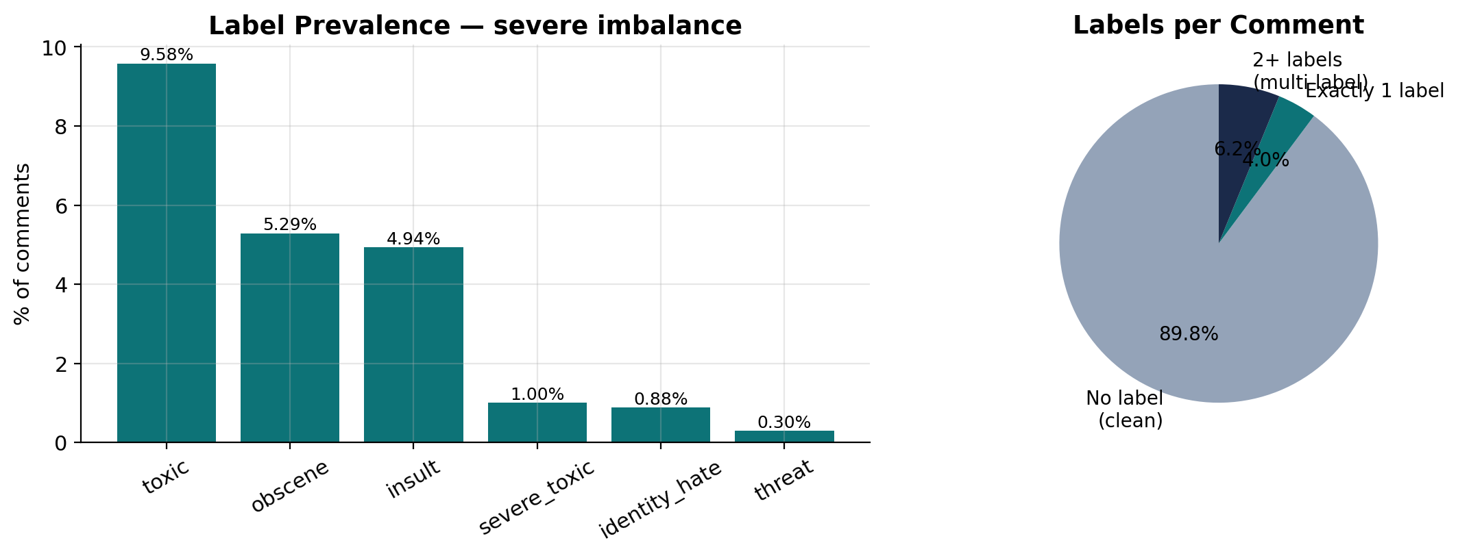
Figure 1: Label prevalence and number of labels per comment in the Jigsaw corpus
The way the labels appear together is also informative. Obscene and insult often appear with toxic, while threat and identity_hate usually stand alone. This supports the multi-label approach, as forcing a single-label choice would miss important details about combined cases.

Length analysis showed a median of 36 words and a 95th percentile of 230. A maximum sequence length of 192 tokens was chosen to keep most of each comment while managing the memory cost of self-attention.
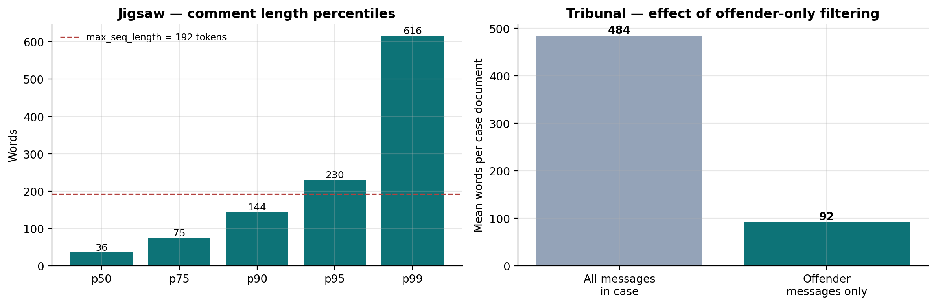
Figure 2: Comment length percentiles for the Jigsaw corpus with the selected sequence limit (left), and the effect of offender-only filtering on Tribunal case document length (right)

Baseline Implementation
The baseline used TF-IDF vectorization with 50,000 features over unigrams and bigrams, sublinear term frequency scaling, and a minimum document frequency of two. For classification, logistic regression was employed in a One-vs-Rest strategy. This approach fits an independent binary classifier for each label when labels are not mutually exclusive. Balanced class weighting was applied. The corpus was divided 80:20, ensuring it was stratified based on whether a comment had any positive label.

Transformer Implementation
The multi-label approach needed several changes from the Phase One pipeline. Models were set up with the problem_type as multi_label_classification. This allowed the head to produce independent logits for each label. The loss function was switched from cross-entropy to binary cross-entropy with logits, treating each label as its own binary decision. Label vectors were represented as floating-point tensors instead of integer indices. During inference, a sigmoid was applied to each logit and thresholded, replacing the argmax operation typically used for single-label tasks.

To handle imbalance, the pos_weight parameter was used. This scaled the impact of positive examples for each label separately. Weights were calculated as the ratio of negative to positive examples in the training set and were capped at 50 to avoid rare labels from destabilizing training. These weights ranged from 9.4 for toxic to the maximum for severe_toxic, threat, and identity_hate.

The dataset was split into 70:15:15, with stratification as mentioned. BERT-base-uncased was fine-tuned with a learning rate of 2e-5, while XLM-RoBERTa-base used a rate of 1e-5. Both models were trained for two epochs with a batch size of 16, weight decay of 0.01, and mixed-precision training. Model selection was based on the mean column-wise ROC AUC of the validation set.

Threshold Calibration and Interpretability

Per-Label Threshold Optimisation
Initial evaluation used a uniform decision threshold of 0.5. However, the positive-class weighting applied during training changes the distribution of predicted probabilities. This means the default may not be suitable. A search for thresholds for each label was conducted, testing values from 0.05 to 0.95 in increments of 0.01. For each label, the value that maximized F1 was selected independently.

Thresholds were fitted only on the validation partition. They were then applied unchanged to the test partition. Fitting on test data would lead to information leakage and artificially boost reported performance. Maintaining this separation is crucial for the validity of the reported improvements.

Attention-Based Attribution
Interpretability was approached through attention attribution. For each input, we extracted and averaged the final-layer attention directed at the classification token across attention heads. This provided a score for each input token that showed how much the pooled representation relied on it.

A crucial implementation detail emerged. Current versions of the Transformers library use a scaled dot-product attention backend by default, which does not return attention weights. As a result, requests for these weights return an empty result. To resolve this, we instantiated models with the eager attention implementation explicitly specified. We also added a guard to raise a helpful error if the attention weights are missing.

It is important to note that attention weights show where a model focuses, but they do not explain why it makes a decision. Their role as an explanation is debated in the literature, and the results in Section 4.5 are presented as suggestive rather than conclusive.

Implementation Challenges

Library Version Incompatibility
The Transformers library changed the name of the evaluation_strategy training argument to eval_strategy, and you cannot assume the version of the hosted environment. Using the wrong name leads to a TypeError during configuration. This issue was fixed by checking the TrainingArguments constructor signature during runtime and choosing the name that the installed version shows. This allows notebooks to run without changes across different versions.

Apparent Checkpoint Loading Failures
Loading pretrained weights produced warnings about missing keys for layer normalization parameters. Randomly initialized layer normalization would stop effective transfer learning. This raised a real concern that the models were not actually pretrained. We resolved the concern by checking the loaded parameter tensors. Layer normalization weights showed means between 0.76 and 0.96 with small standard deviations, which aligns with trained values instead of random ones. The warnings come from a change in naming conventions between checkpoint format versions.

Training Instability in XLM-RoBERTa
As noted in Section 3.2.4, XLM-RoBERTa initially collapsed to constant prediction. The diagnostic used was comparing the macro F1 score against the majority-class dummy; identical values show that the model learned nothing beyond the class prior. The solution was to lower the learning rate and extend the warm-up period. This change reflects the greater sensitivity of the larger multilingual model when dealing with a small training set.
Evaluation and Results
This chapter reports the outcomes from both phases and evaluates them against the goals of Chapter 1. Results are presented for the Tribunal corpus first, then for the Jigsaw corpus, and finally, a comparison is made since this contrast is the main finding.

Evaluation Methodology
Metric selection needs careful consideration in cases of severe imbalance. Accuracy does not provide useful information when one class dominates. A majority-class rule can score high without being truly discriminative. Similarly, weighted F1 also gets influenced by the largest class. Therefore, we adopted macro F1, which averages per-class F1 equally regardless of support, as the main metric for the multi-class Tribunal experiments.

For the multi-label Jigsaw experiments, we used mean column-wise ROC AUC. This measure was part of the original competition and does not depend on thresholds. It evaluates ranking quality instead of performance at a specific boundary. Micro and macro F1 are reported alongside to show behavior at a fixed operating point. A majority-class dummy was tested on each partition to set a trivial floor. Reporting performance without this reference risks suggesting that a score requiring no learning is meaningful.

Phase One Results: Tribunal Corpus
Table 2: Model performance on the Tribunal corpus (four-class, case-level)
Model | Weighted F1 | Macro F1 | Improvement over dummy
BERT-base-uncased | 0.303 | 0.286 | +125%
TF-IDF + Logistic Regression | 0.297 | 0.273 | +115%
XLM-RoBERTa-base | 0.288 | 0.267 | +110%
Majority-class dummy | 0.172 | 0.127 | —

All three trained models performed better than the dummy, showing that each learned a real signal. However, they are within 0.019 macro F1 of each other. BERT's margin of 0.013 over the baseline came from a single run with one configuration and is likely due to random variation. The right conclusion is that the approaches did similarly, not that transformer architectures provided an edge.
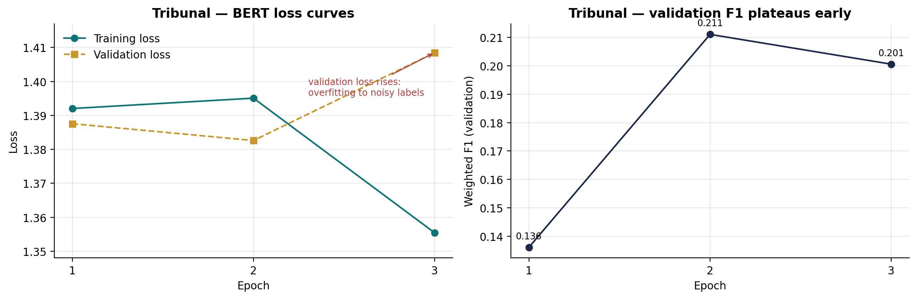
Figure 5: BERT training and validation loss on the Tribunal corpus (left) and validation F1 by epoch (right). Validation loss rises after the second epoch while training loss falls, indicating the model begins fitting label noise
Error analysis clarifies this convergence. The most common mistakes were between Verbal Abuse and Offensive Language (182 instances), Offensive Language and Negative Attitude (133 instances), and in the opposite direction (132 instances). These categories describe overlapping behavior, and the high level of confusion in both directions shows that the differences were not applied consistently in the source data. A model cannot learn a boundary that is not consistently present in its training signal.

A follow-up experiment combined the three overlapping categories into one Toxic Speech class versus Gameplay Sabotage. The weighted F1 score rose to 0.819. However, the floor for the majority class in this binary problem is 0.847, which means the merged classifier did worse than a rule that always predicts the larger class. The noted improvement is a result of simplifying this to an imbalanced binary problem, and this is mentioned here to avoid that misunderstanding.

Phase Two Results: Jigsaw Corpus
Table 3: Model performance on the Jigsaw corpus (six-label, multi-label, threshold 0.5)
Model | Mean ROC AUC | Micro F1 | Macro F1
BERT-base-uncased | 0.9895 | 0.723 | 0.627
XLM-RoBERTa-base | 0.9823 | 0.649 | 0.506
TF-IDF + One-vs-Rest LR | 0.9772 | 0.704 | 0.586

BERT achieved the best performance on all three measures, with a mean column-wise ROC AUC of 0.9895. Unlike Phase One, the models are clearly separated now. BERT outperforms the baseline by 0.041 macro F1, which is a much bigger margin than what we saw on the Tribunal corpus.

XLM-RoBERTa performed worse than BERT. This matches the data: the Jigsaw comments are in English. Therefore, XLM-RoBERTa's vocabulary of around 250,000 tokens doesn't help, and its larger number of parameters increases the risk of overfitting. The multilingual model would be expected to perform better on a cross-lingual corpus, but this one is not.
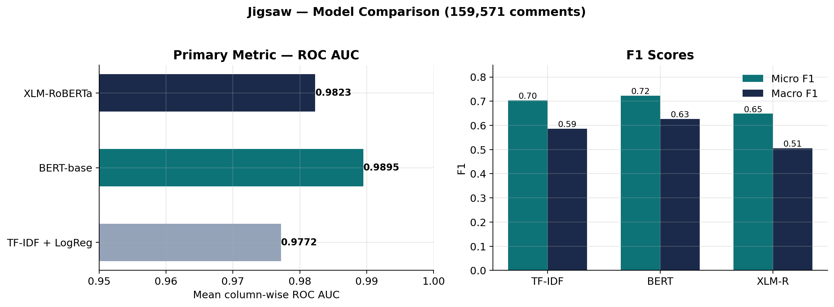
Figure 6: Model comparison on the Jigsaw corpus. ROC AUC is shown on a restricted axis (0.95-1.00) so differences remain visible
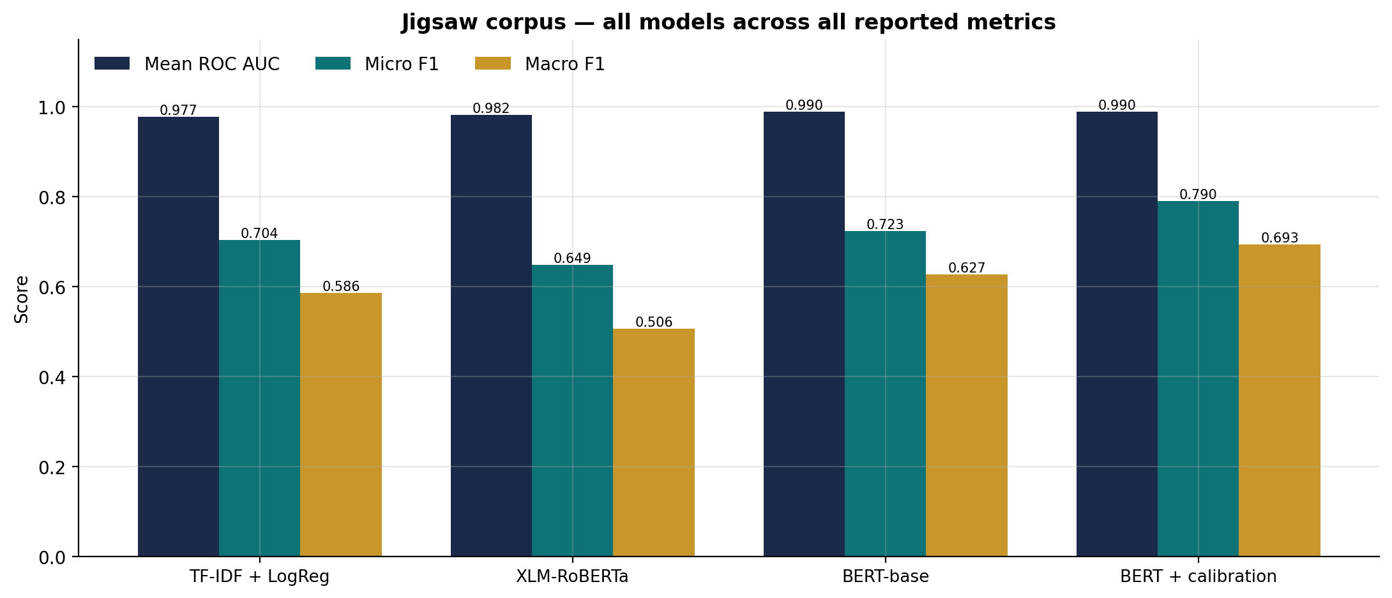
Figure 7: All evaluated models across all reported metrics, including the calibrated BERT configuration

Threshold Calibration
Per-label analysis at the default threshold showed a clear pattern. ROC AUC stayed above 0.985 for every label, including threat, which appears in only 84 test instances. Meanwhile, F1 dropped to 0.418 for severe_toxic. A high AUC indicates a correct ranking, while a low fixed-threshold F1 suggests that 0.5 is not a suitable decision boundary.
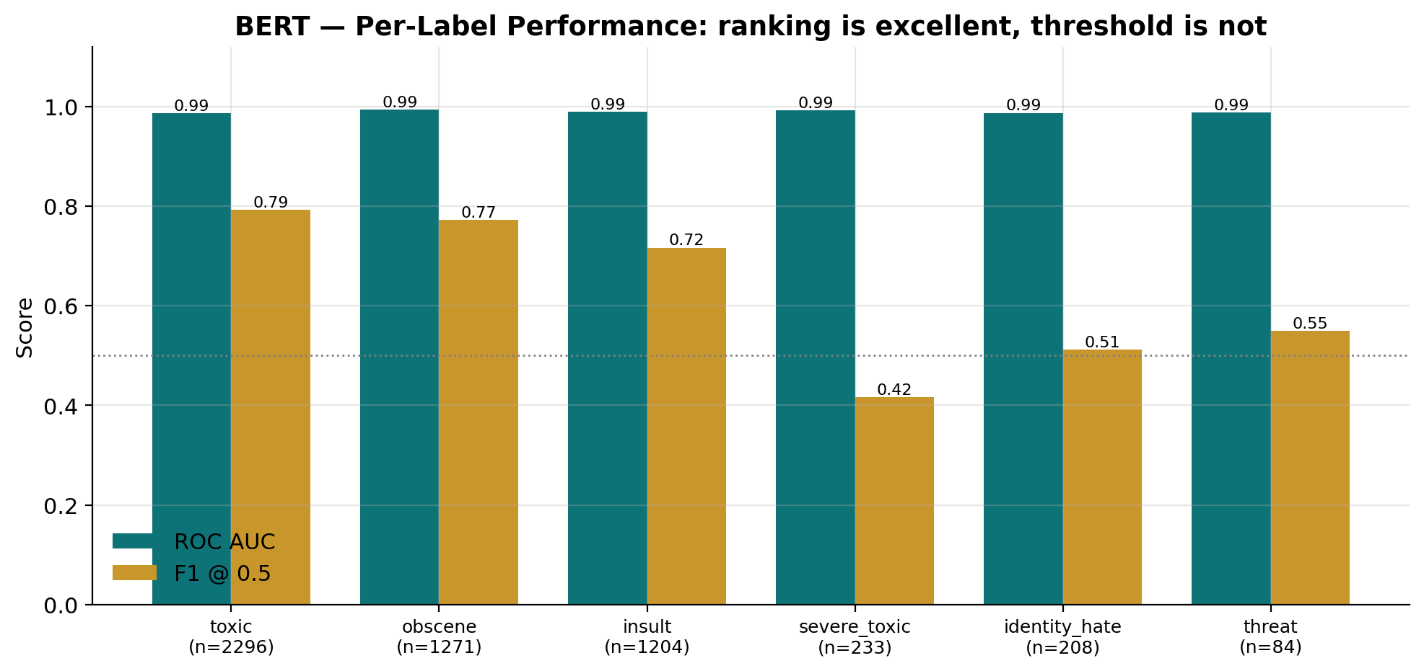
Figure 8: Per-label ROC AUC against F1 at the fixed 0.5 threshold. AUC remains above 0.985 for every label while F1 falls sharply on rarer categories, indicating a threshold effect rather than a ranking failure
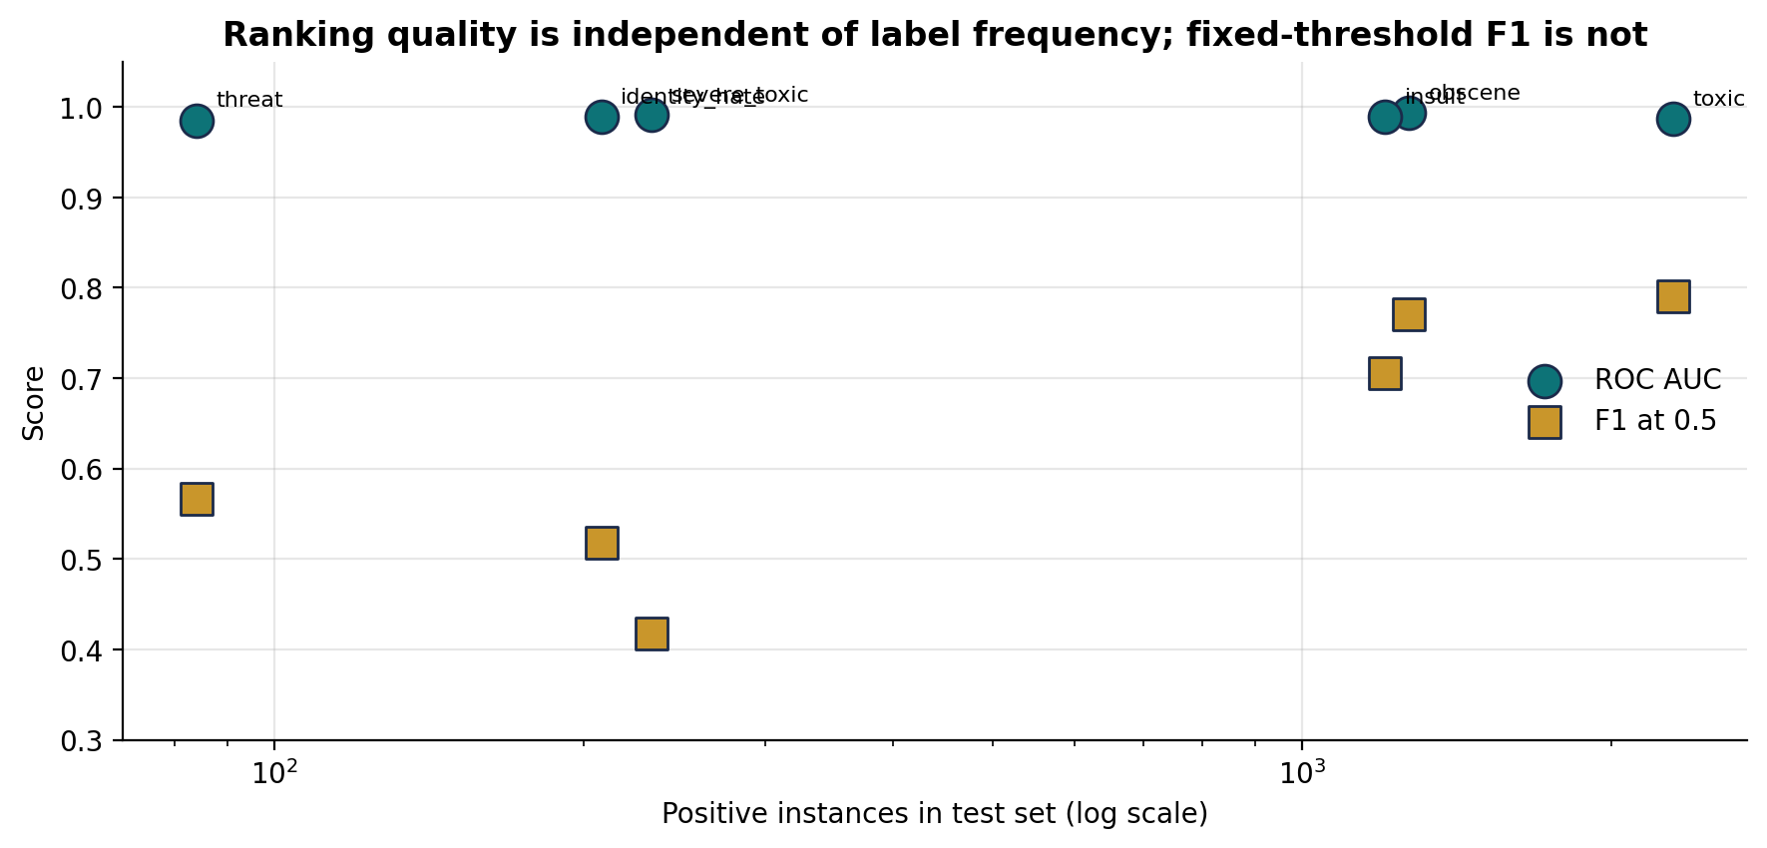
Figure 9: Ranking quality plotted against label frequency. ROC AUC is invariant to support while fixed-threshold F1 degrades sharply as positive instances become scarce
Table 4: Effect of per-label threshold calibration (BERT, Jigsaw test partition)
Label | Support | ROC AUC | F1 @ 0.5 | Tuned threshold | F1 tuned | Gain
toxic | 2,296 | 0.9867 | 0.790 | 0.94 | 0.832 | +0.042
obscene | 1,271 | 0.9934 | 0.771 | 0.95 | 0.844 | +0.073
insult | 1,204 | 0.9895 | 0.706 | 0.94 | 0.782 | +0.076
severe_toxic | 233 | 0.9916 | 0.418 | 0.95 | 0.530 | +0.112
identity_hate | 208 | 0.9894 | 0.518 | 0.85 | 0.605 | +0.088
threat | 84 | 0.9854 | 0.567 | 0.78 | 0.567 | +0.001

Aggregate performance improved significantly. Micro F1 increased from 0.720 to 0.790, and macro F1 rose from 0.628 to 0.693. This is a 10.4 percent improvement achieved without any changes to the trained model. The biggest gains were seen in the rarest labels. Severe_toxic improved by 0.112, and identity_hate increased by 0.088. This shows that the fixed threshold had penalized the categories where performance was weakest.
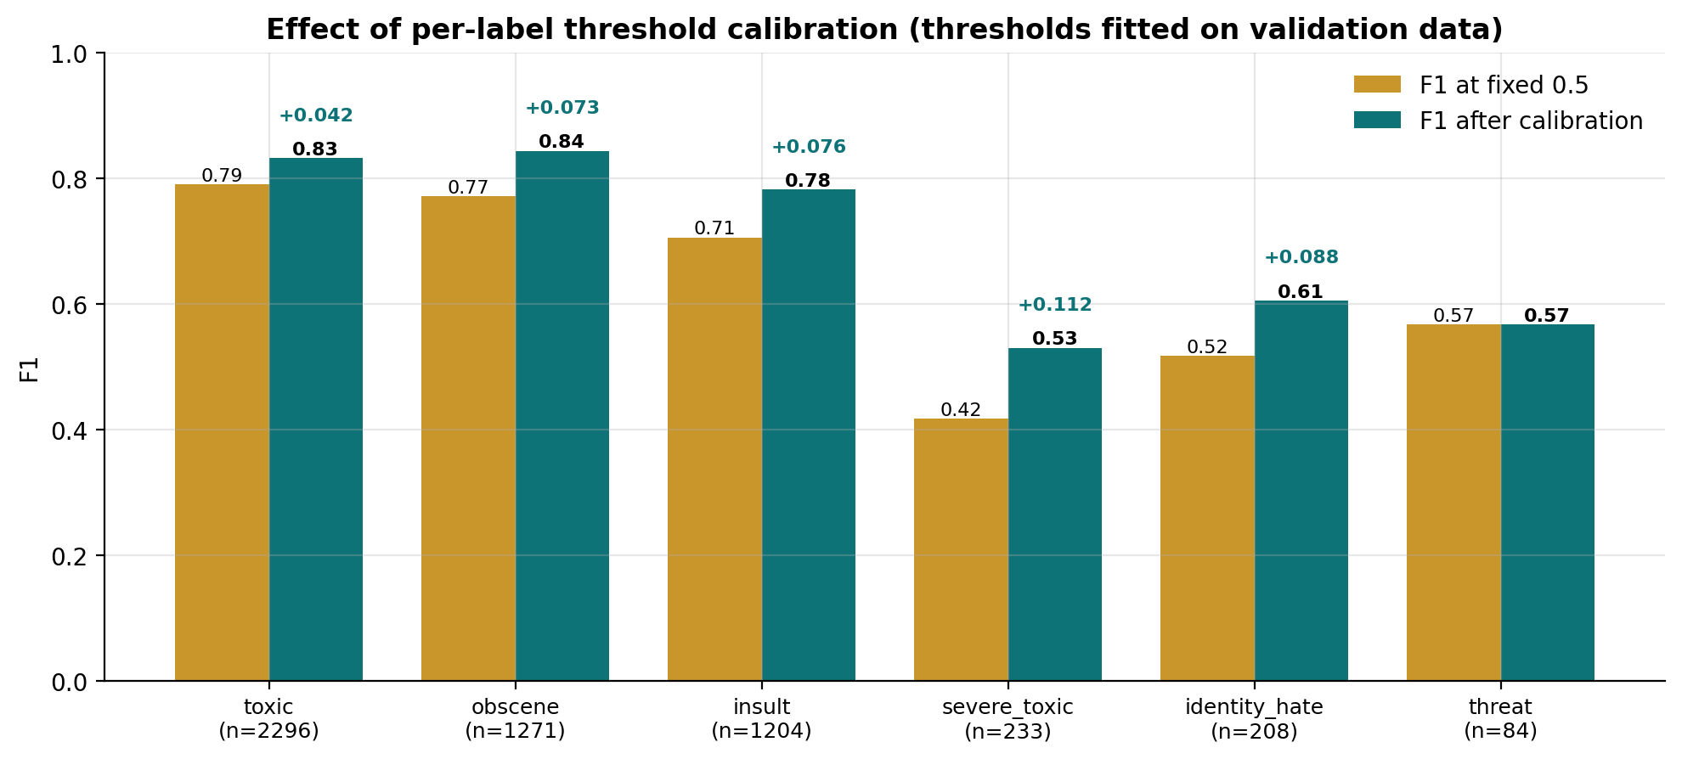
Figure 10: Per-label F1 before and after threshold calibration. Gains are largest on the rarest labels
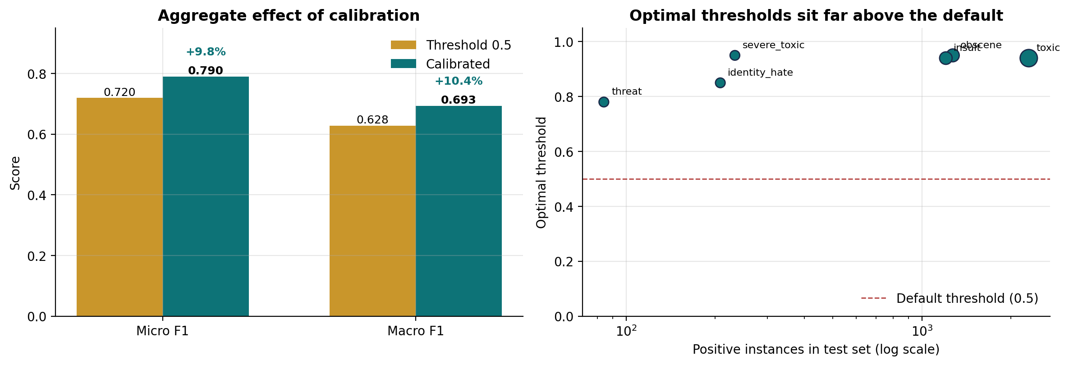
Figure 11: Aggregate effect of calibration on micro and macro F1 (left), and the relationship between label frequency and optimal threshold (right)
The optimal thresholds are between 0.78 and 0.95, not near 0.5. This is due to the positive-class weighting used during training, which raises predicted probabilities for minority labels. This shows that calibration should be seen as a vital part of the pipeline, not just an optional improvement when weighted loss functions are applied.

The only exception is threat, which increased by only 0.001. With 84 positive test instances, the threshold estimates for this label vary greatly, so no reliable improvement can be claimed.

Interpretability Analysis
Attention attribution was applied to the most confidently classified toxic comments. The tokens that received the most attention were mainly explicit profanity and slurs directed at individuals. This shows that predictions rely on lexical content tied to the target categories instead of misleading factors like comment length or formatting.

A more revealing finding came from looking at a comment in an online gaming exchange. This comment was labeled as toxic in the ground truth, but the model gave it a threat probability of 0.923, which is above the set threshold. The attention analysis revealed that the highest-weighted tokens were destroy, death, and duel. These words were used figuratively to describe gameplay, not as real threats to harm anyone.

This represents a clear and understandable failure. The model has connected violent language with the threat category, but this link does not hold up in contexts where such language is normal and not literal. This has real-world implications: a classifier trained on Wikipedia discussions should not be used on gaming platforms without adjusting for that context, as it would mistakenly flag ordinary gaming conversations as harmful. It also highlights the importance of interpretability analysis, since this issue would not show up in overall metrics.

Cross-Corpus Comparison
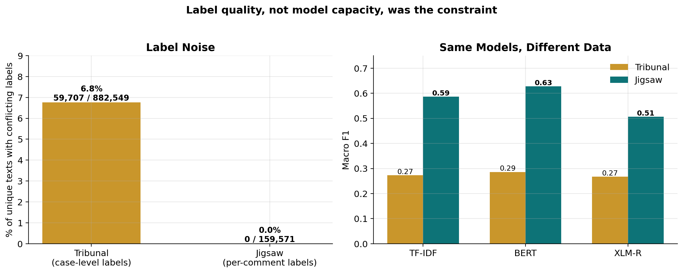
Figure 12: Label conflict in each corpus (left) and the macro F1 achieved by identical model architectures on each (right)
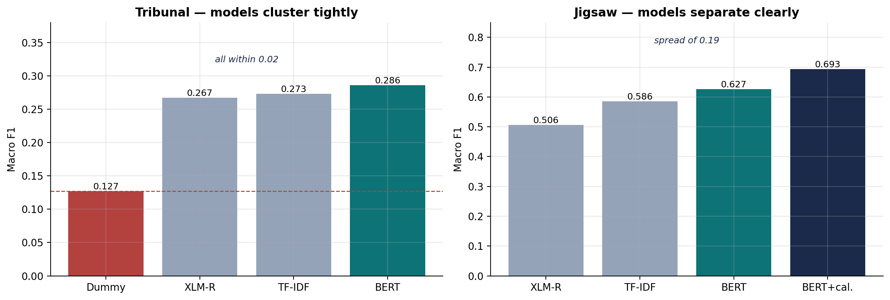
Figure 13: Model dispersion on each corpus. On the Tribunal data all architectures fall within 0.02 macro F1 of one another; on Jigsaw they span 0.19
Table 5: Comparison of the two corpora and resulting performance
Property | Tribunal | Jigsaw
Instances | 1,697,193 messages / 10,058 cases | 159,571 comments
Unit of labelling | Per case, inherited by messages | Per individual comment
Conflicting labels | 59,707 of 882,549 unique texts | 0 of 159,571
Task formulation | Four-class, single-label | Six-label, multi-label
Best macro F1 | 0.286 (BERT) | 0.693 (BERT, calibrated)
Best ROC AUC | Not applicable | 0.9895 (BERT)

The comparison highlights label granularity as the main variable. The same architectures, trained using the same libraries and tested under the same protocol, achieve a macro F1 of about 0.27 to 0.29 on the corpus with inherited case-level labels and 0.51 to 0.69 on the corpus with per-instance labels. BERT more than doubles its macro F1 across the two corpora.

It's important to recognize that the corpora differ not just in label granularity; they vary in domain, task formulation, and the number of target categories. This means the comparison doesn’t form a controlled experiment focused on one variable, which limits the inference drawn. However, three independent pieces of evidence support the findings: the measured label conflict, the consistent performance of all architectures on the first corpus, and the clustering of errors in semantically similar categories. Together, these points suggest that label quality was the main issue in Phase One.

Statistical Considerations
The comparison highlights label granularity as the main variable. The same architectures, trained using the same libraries and tested under the same protocol, achieve a macro F1 of about 0.27 to 0.29 on the corpus with inherited case-level labels and 0.51 to 0.69 on the corpus with per-instance labels. BERT more than doubles its macro F1 across the two corpora.

It's important to recognize that the corpora differ not just in label granularity; they vary in domain, task formulation, and the number of target categories. This means the comparison doesn’t form a controlled experiment focused on one variable, which limits the inference drawn. However, three independent pieces of evidence support the findings: the measured label conflict, the consistent performance of all architectures on the first corpus, and the clustering of errors in semantically similar categories. Together, these points suggest that label quality was the main issue in Phase One.

Comparison with Published Results
Contextualizing the results against published work offers an external check on implementation accuracy. Transformer models fine-tuned on the Jigsaw corpus usually report mean column-wise ROC AUC values between 0.98 and 0.99. The value of 0.9895 obtained here falls within this range. This supports the idea that the implementation is solid and that the multi-label configuration, loss function, and training process were applied correctly.

Any direct numerical comparison beyond this should be approached carefully. Published figures come from different data partitions, and the highest reported values often result from ensembles of multiple models or larger architectures than the base-sized models used here. This comparison shows that the implementation is competent but does not claim that it is the best available.

No comparable published baseline exists for the Tribunal corpus, which has not been widely studied in academic work. Therefore, the results reported in Section 4.2 stand without external reference. This presents a limitation, as it is unclear whether the performance achieved reflects the corpus ceiling or a flaw in the chosen method. However, the convergence of three different models achieving similar performance suggests the former interpretation.

Related Works
The results here can be compared to previous work. Wulczyn et al. [6] created the Wikipedia personal attacks corpus that supports the Jigsaw dataset by using independent annotation for each item. The zero label conflict discussed in Section 3.4.1 matches that approach. Davidson et al. [4] noted a consistent mix-up between hate speech and simply offensive language. They blamed this on real confusion in the definitions rather than flaws in the model. This finding is similar to the pattern seen in the Tribunal corpus in Section 4.2.

Transformer results on the Jigsaw corpus typically show a mean column-wise ROC AUC between 0.98 and 0.99. The value of 0.9895 found here fits within that range, showing that the implementation is reliable and competitive with existing studies. The unique advantage of this project is not just that number, but the comparison with a corpus that has inherited labels. This approach measures the cost of that annotation design and shows that threshold calibration can recover an extra 10.4 percent of macro F1 without any added training cost.

Evaluation Against Objectives
The systematic data quality assessment achieved its goal and proved to be crucial. The assessment showed that the originally outlined task lacked support from the available variables and uncovered the label inheritance problem. The goals of implementing a classical baseline with a simple reference and comparing transformer architectures under a shared protocol were met for both corpora. The aim for metrics suitable for imbalance and proper threshold calibration was fulfilled, resulting in a 10.4 percent improvement in macro F1. The goal of interpretability was also achieved, revealing a consistent false-positive mechanism.

However, one objective from the original proposal could not be accomplished. The investigation of contextual features like match outcome and player role was not possible since those fields are not present in the corpus. The analysis focused on message origin, applying a filter to the reported player's own messages.
Conclusion

Summary of Findings
This project aimed to develop and evaluate transformer-based classifiers for detecting toxic language. It accomplished this goal and, along the way, revealed important insights about how annotation design relates to model performance.

On the Jigsaw corpus, fine-tuned BERT achieved a mean column-wise ROC AUC of 0.9895. This result aligns with published findings on the dataset and confirms that the implementation works well. Per-label threshold calibration improved the macro F1 score from 0.628 to 0.693 without changing the model. This shows that calibration is necessary, not optional, when using weighted loss functions.

The more significant contribution concerns the comparison between different corpora. On the Tribunal corpus, where labels are assigned per moderation case and shared by every message, all three architectures reached within 0.02 of each other's macro F1 scores, settling around 0.28. In contrast, the same architectures achieved scores between 0.51 and 0.69 on data with individual annotations. We quantified label inconsistency: 59,707 out of 882,549 unique message strings had conflicting labels, while there were none in the second corpus.

The interpretability analysis revealed a consistent failure mode. Figurative violence in gaming discussions was wrongly classified as a genuine threat. This occurred with attention focused on words such as destroy, death, and duel. This issue has direct implications for deploying models in different domains and is not detectable through aggregate metrics.

Limitations
Several limitations qualify these conclusions and are stated explicitly. Each model was trained once, using a single random seed and one hyperparameter setup. Differences of around 0.01 to 0.02 in macro F1, such as BERT's advantage over the baseline on the Tribunal corpus, may not be separable from run-to-run variance based on this evidence. Repeated runs with confidence intervals would be needed to support claims at that level.

The cross-corpus comparison is not a controlled experiment. The corpora differ in their domain, how tasks are formulated, the number of categories, and the detail of labels. Thus, while the performance difference can be linked to annotation design through supporting evidence, this conclusion is based on inference rather than certainty.

The maximum sequence length was set to 192 tokens for the transformers, while the classical baseline processed complete documents. Although this includes most comments, it creates a slight disadvantage for the transformer models in the comparison.

Attention weights show where a model focuses, but they do not establish causal links, and their role as an explanation is debated. The findings on interpretability should be seen as suggestive. Finally, no specific bias audit was conducted, and the models' behavior regarding neutral discussions of protected characteristics is still not clearly defined.

Future Work
Several directions follow naturally. Repeating all experiments with multiple random seeds would help determine if the differences between architectures are statistically significant. A controlled study on the effect of label granularity could be set up by artificially adding inherited labels within a single corpus, keeping the domain and task constant, and measuring performance as the noise level changes.

The domain transfer failure identified in Section 4.5 needs direct investigation. Continuing pretraining on in-domain gaming text before fine-tuning would test if the mix of figurative and literal violence can be corrected. Additionally, a systematic bias audit that measures false-positive rates on neutral text mentioning protected traits should happen before considering any deployment.

Finally, different approaches to the rare-label problem deserve comparison. Focal loss, targeted oversampling, and threshold calibration each tackle the same challenge in unique ways, and a controlled comparison would reveal which is most effective in this context.

Controlled Study of Label Granularity
The main finding of this project comes from comparing different corpora that vary in several ways at the same time. A controlled study would significantly improve this finding. Starting with a corpus that has reliable instance labels, we could create artificial groups. Each group would receive a single label based on its members, and we would assign that label back to every instance. Changing the size of the groups would allow us to measure performance based on the added label noise while keeping the domain, task, and architecture the same. This would show whether the relationship is linear, has a threshold, or has another structure, and it would clarify an effect that our current comparison can only suggest.

Domain Adaptation for Gaming Discourse
The false-positive mechanism discussed in Section 4.5 shows that figurative violence in gaming conversation was classified as a genuine threat. This points to a specific and testable solution. Continuing pretraining on a large set of unlabelled gaming chat, before fine-tuning on labelled toxicity data, would help the model learn the typical non-literal use of violent language in that area. It's unclear if this approach will clarify the confusion without harming the detection of genuine threats. A controlled experiment could provide an answer to this question. The Tribunal corpus, while not suitable for supervised training, includes about 1.7 million messages of the needed unlabelled in-domain text.

Systematic Bias Audit
No bias evaluation was done in this project. This needs to happen before any deployment can be considered. A structured audit would create neutral statements that include protected traits and measure false-positive rates. This would show whether the model punishes the simple mention of identity terms, regardless of any negative intent. If any disparities are found, we could look into strategies like counterfactual data augmentation and instance reweighting. This is not just a nice-to-have improvement. A toxicity classifier with identity-term bias harms the very groups it aims to protect.

Comparison of Imbalance Strategies
This project focused on class imbalance by using positive-class weighting and post-hoc threshold calibration. Several alternatives deserve thorough comparison under the same conditions: focal loss, which reduces the weight of well-classified examples; targeted oversampling of minority instances; and asymmetric loss functions meant for multi-label problems with extreme imbalance. Since threshold calibration alone improved the macro F1 by 10.4 percent, understanding how much of the remaining gap comes from loss design instead of the decision rule would be useful.

Model Scale and Architecture
Base-sized models were used throughout to allow a comparison of two architectures within the available compute budget. Larger variants, as well as architectures that include disentangled attention or better position encoding, consistently outperform base-sized BERT on classification tests. They should improve overall performance here. A more interesting question is whether the label-quality ceiling seen on the Tribunal corpus would limit larger models the same way. If the ceiling really comes from the labels and not from the model's ability, then increasing capacity should offer no benefit. Confirming that prediction would significantly support the main argument.

Reflection
The most important lesson focuses on the order of the project steps. The original proposal outlined a simple sanction prediction task and identified contextual features for investigation. However, neither aspect was backed by the data, and this was only discovered after the proposal was approved. The schema should have been checked directly before committing to the methodology instead of depending on the dataset's published description. This stands out as the clearest improvement that could have been made to the project.

Recovering from that situation proved to be a valuable experience. The initial results were disappointing. The options available were to either present those results without explanation or to dig into the reasons behind them. Opting for the latter led to the development of the quantified label-conflict measure, the case-level aggregation experiment, and ultimately the cross-corpus comparison, which collectively form the main contribution of the project. A weak result, when properly diagnosed, yielded more insights than a satisfactory result accepted without question would have.

Another important lesson relates to choosing metrics. Early evaluations used weighted F1, where a simple majority-class rule scored 0.847 on the combined binary problem while the trained classifier scored 0.819. Without a dummy baseline for comparison, that score could easily have been presented as a success. This project would continue to evaluate every model alongside a basic reference.

On a technical level, the importance of verifying assumptions was reinforced repeatedly. Warnings during checkpoint loading indicated that the models might not be pretrained, but checking the parameter statistics confirmed that they were. Additionally, a default attention backend quietly produced no attention weights, which would have led to failures in the interpretability analysis if it hadn't been tested beforehand. In both instances, the solutions came from observing the system's actual behavior rather than assuming what it should be doing.

References
[1] J. Devlin, M.-W. Chang, K. Lee, and K. Toutanova, "BERT: Pre-training of deep bidirectional transformers for language understanding," in Proc. NAACL-HLT, Minneapolis, MN, USA, 2019, pp. 4171–4186.
[2] A. Conneau et al., "Unsupervised cross-lingual representation learning at scale," in Proc. 58th Annu. Meeting Assoc. Comput. Linguistics, 2020, pp. 8440–8451.
[3] A. Vaswani et al., "Attention is all you need," in Advances in Neural Information Processing Systems, vol. 30, 2017, pp. 5998–6008.
[4] T. Davidson, D. Warmsley, M. Macy, and I. Weber, "Automated hate speech detection and the problem of offensive language," in Proc. 11th Int. AAAI Conf. Web and Social Media (ICWSM), 2017, pp. 512–515.
[5] A. M. Founta et al., "Large scale crowdsourcing and characterization of Twitter abusive behavior," in Proc. 12th Int. AAAI Conf. Web and Social Media (ICWSM), 2018, pp. 491–500.
[6] E. Wulczyn, N. Thain, and L. Dixon, "Ex machina: Personal attacks seen at scale," in Proc. 26th Int. Conf. World Wide Web (WWW), 2017, pp. 1391–1399.
[7] Y. Liu et al., "RoBERTa: A robustly optimized BERT pretraining approach," arXiv:1907.11692, 2019.
[8] F. Pedregosa et al., "Scikit-learn: Machine learning in Python," J. Machine Learning Research, vol. 12, pp. 2825–2830, 2011.
[9] T. Wolf et al., "Transformers: State-of-the-art natural language processing," in Proc. Conf. Empirical Methods in Natural Language Processing: System Demonstrations, 2020, pp. 38–45.

Appendices

Appendix A Artefact and Datasets

A.1 Artefact Description
The artefact that comes with this report contains five Jupyter notebooks created and run in the Kaggle Notebooks environment. Each notebook completed its run with GPU acceleration on when needed. The saved versions include both the source code and the outputs, allowing you to trace every figure and table in this document back to the code that produced it. You don't need to install anything to view the artefact. The saved notebook versions display in a browser with all outputs preserved.
Table 14: Artefact notebook inventory
Notebook | Corpus | Purpose | Runtime
1 | Tribunal | Data quality assessment, visualisation and classical baseline | 10 min (CPU)
2 | Tribunal | Transformer fine-tuning and model comparison | 50 min (GPU)
3 | Jigsaw | Data quality assessment, visualisation and One-vs-Rest baseline | 10 min (CPU)
4 | Jigsaw | Multi-label transformer fine-tuning and comparison | 3 h (GPU)
5 | Jigsaw | Threshold calibration, interpretability and evaluation figures | 50 min (GPU)

A.2 Datasets
Two publicly available corpora were used. Neither required licensing arrangements, and neither contains direct personal identifiers that were used as model input.

The first corpus is the League of Legends Tribunal Chat Logs, published on Kaggle. It includes 1,697,193 chat messages from 10,058 moderation cases. The data records the message text, the sender's relationship to the reported player, match details, and the offence category cited. Labels are assigned at the case level and apply to each message. This corpus was used in Phase One, and the analysis is reported in Sections 3.2 and 4.2.

The second corpus is the Jigsaw Toxic Comment Classification Challenge, also available on Kaggle. It comes from the Wikipedia personal attacks dataset of Wulczyn et al. This corpus contains 159,571 comments from Wikipedia talk pages, each marked with six independent binary labels: toxic, severe toxic, obscene, threat, insult, and identity hate. Labels are assigned to each individual comment. This corpus was used in Phase Two and is analyzed in Sections 3.4, 4.3, 4.4, and 4.5.

A.3 Reproducing the Results
To reproduce the reported results, attach the relevant corpus to a Kaggle notebook using the Add Input control. Enable GPU acceleration and internet access in the notebook settings, then execute all cells. The notebooks automatically locate their input file and provide a clear error message if the corpus has not been attached. A fixed random seed of 42 controls all data partitioning and model initialization, and all data splits are stratified to keep class representation consistent across partitions.

Two environment dependencies are important to note. The Transformers library renamed one of its training arguments between versions, and the notebooks check at runtime which name is used by the installed version. Interpretability analysis requires explicitly specifying the eager attention implementation during model instantiation since the default backend does not return attention weights. This is managed in the model loading code with an explicit check.

A.4 Output Files
Executing the notebooks creates the artefacts mentioned in Chapters 3 and 4. These include a model comparison table in comma-separated format, per-label threshold values in JSON format, threshold calibration results in comma-separated format, and the figure files included in this report. All these files are saved in the notebook working directory and are kept within the saved notebook version.

Appendix B Full Classification Reports
Complete per-label classification reports generated by the evaluation notebooks are reproduced here for reference.
Table 6: BERT per-label classification report, Jigsaw test partition, threshold 0.5
Label | Precision | Recall | F1 | Support
toxic | 0.7220 | 0.8720 | 0.7902 | 2,296
severe_toxic | 0.2699 | 0.9356 | 0.4176 | 233
obscene | 0.7093 | 0.8442 | 0.7708 | 1,271
threat | 0.4359 | 0.8095 | 0.5667 | 84
insult | 0.6301 | 0.8014 | 0.7058 | 1,204
identity_hate | 0.3852 | 0.7885 | 0.5176 | 208

Table 7: BERT per-label results after threshold calibration
Label | Threshold | F1 at 0.5 | F1 calibrated | Absolute gain | Relative gain
toxic | 0.94 | 0.7902 | 0.8320 | +0.0418 | +5.3%
severe_toxic | 0.95 | 0.4176 | 0.5300 | +0.1124 | +26.9%
obscene | 0.95 | 0.7708 | 0.8436 | +0.0728 | +9.4%
threat | 0.78 | 0.5667 | 0.5674 | +0.0007 | +0.1%
insult | 0.94 | 0.7058 | 0.7817 | +0.0759 | +10.8%
identity_hate | 0.85 | 0.5176 | 0.6051 | +0.0875 | +16.9%

Table 8: Aggregate metrics before and after calibration
Metric | Threshold 0.5 | Calibrated | Relative gain
Micro F1 | 0.7197 | 0.7899 | +9.8%
Macro F1 | 0.6281 | 0.6933 | +10.4%
Mean ROC AUC | 0.9895 | 0.9895 | unchanged (threshold-independent)

Appendix C Hyperparameter Configuration
Table 9: Complete hyperparameter settings for all transformer experiments
Parameter | BERT (Jigsaw) | XLM-R (Jigsaw) | BERT (Tribunal) | XLM-R (Tribunal)
Checkpoint | bert-base-uncased | xlm-roberta-base | bert-base-uncased | xlm-roberta-base
Learning rate | 2e-5 | 1e-5 | 2e-5 | 5e-6
Epochs | 2 | 2 | 4 | 4
Batch size | 16 | 16 | 4 (accum. 2) | 4 (accum. 2)
Max sequence length | 192 | 192 | 512 | 512
Weight decay | 0.01 | 0.01 | 0.01 | 0.01
Warm-up | 6% of steps | 6% of steps | 10% of steps | 20% of steps
Loss function | BCE with logits | BCE with logits | Weighted CE | Weighted CE
Imbalance handling | pos_weight (cap 50) | pos_weight (cap 50) | Balanced weights | Balanced weights
Selection metric | Mean ROC AUC | Mean ROC AUC | Macro F1 | Macro F1
Mixed precision | Enabled | Enabled | Enabled | Enabled
Random seed | 42 | 42 | 42 | 42

Table 10: Positive-class weights applied in the multi-label loss function
Label | Positive instances (train) | Negative instances | Computed weight | Applied weight
toxic | 10,706 | 101,394 | 9.47 | 9.47
severe_toxic | 1,117 | 110,983 | 99.36 | 50.00 (capped)
obscene | 5,914 | 106,186 | 17.95 | 17.95
threat | 335 | 111,765 | 333.63 | 50.00 (capped)
insult | 5,514 | 106,586 | 19.33 | 19.33
identity_hate | 984 | 111,116 | 112.92 | 50.00 (capped)

Appendix D Key Code Listings
Selected components are reproduced here. Complete notebooks are provided as described in Appendix C.

G.1 Multi-label weighted loss
class MultiLabelTrainer(Trainer):
def __init__(self, pos_weight=None, **kw):
super().__init__(**kw)
self.pos_weight = pos_weight

def compute_loss(self, model, inputs, return_outputs=False, **kwargs):
labels = inputs.pop('labels')
outputs = model(**inputs)
logits = outputs.logits
w = self.pos_weight.to(logits.device) if self.pos_weight is not None else None
loss = nn.BCEWithLogitsLoss(pos_weight=w)(logits, labels.float())
return (loss, outputs) if return_outputs else loss

G.2 Label-conflict measurement
# Counts unique texts appearing under more than one label
conflicts = df.groupby(text_col)[label_col].nunique()
print('Conflicting:', (conflicts > 1).sum())
print('Unique texts:', len(conflicts))

G.3 Per-label threshold optimisation
best_thr = {}
for i, L in enumerate(LABELS):
grid = np.arange(0.05, 0.96, 0.01)
f1s = [f1_score(Y_val[:, i], (val_prob[:, i] >= t).astype(int),
zero_division=0) for t in grid]
best_thr[L] = float(grid[int(np.argmax(f1s))])
# Thresholds fitted on validation only, then applied unchanged to test

G.4 Attention attribution
# eager attention is required: the default SDPA backend
# does not return attention weights
model = AutoModelForSequenceClassification.from_pretrained(
MODEL_NAME, num_labels=NUM_LABELS,
problem_type='multi_label_classification',
attn_implementation='eager')

out = model(**enc, output_attentions=True)
att = out.attentions[-1][0].mean(0)[0] # last layer, mean heads, CLS row
toks = tokenizer.convert_ids_to_tokens(enc['input_ids'][0])

G.5 Version-agnostic training arguments
# transformers renamed evaluation_strategy to eval_strategy;
# detect which the installed version exposes
_TA = set(inspect.signature(TrainingArguments.__init__).parameters)
_EVAL_KEY = 'eval_strategy' if 'eval_strategy' in _TA else 'evaluation_strategy'

Appendix E Tribunal Corpus Detailed Results
Table 11: Tribunal corpus label distribution before filtering
Offence category | Cases | Retained
Verbal Abuse | 3,343 | Yes
Negative Attitude | 2,931 | Yes
Offensive Language | 2,562 | Yes
Assisting Enemy Team | 1,025 | Yes
Spamming | 167 | No (below 200 threshold)
Inappropriate Name | 30 | No (below 200 threshold)

Table 12: Effect of modelling strategy on the Tribunal corpus
Strategy | Weighted F1 | Change
Message-level, balanced class weights | 0.188 | baseline
Message-level, unweighted | 0.254 | +35.1%
Case-level aggregation | 0.297 | +58.0%

Table 13: Most frequent misclassifications, Tribunal corpus
True category | Predicted category | Count
Verbal Abuse | Offensive Language | 182
Offensive Language | Negative Attitude | 133
Negative Attitude | Offensive Language | 132
Verbal Abuse | Negative Attitude | 115

The two-way nature of these confusions is significant. Verbal Abuse and Offensive Language are mixed up in both directions at similar rates, just like Offensive Language and Negative Attitude. A model that learned a true but flawed boundary would likely show uneven errors, with confusion leaning one way. Equal confusion at this level suggests that there is no clear boundary in the labels themselves.
The artefact consists of five Jupyter notebooks executed on Kaggle with outputs preserved:
- Notebook 1 (Tribunal): data quality assessment, visualisation and classical baseline.
- Notebook 2 (Tribunal): transformer fine-tuning and model comparison.
- Notebook 3 (Jigsaw): data quality assessment, visualisation and One-vs-Rest baseline.
- Notebook 4 (Jigsaw): multi-label transformer fine-tuning and comparison.
- Notebook 5 (Jigsaw): threshold calibration and attention-based interpretability.
Datasets: the League of Legends Tribunal Chat Logs corpus and the Jigsaw Toxic Comment Classification Challenge corpus, both publicly available on Kaggle.

